Retele /22 – Popescu Dragos

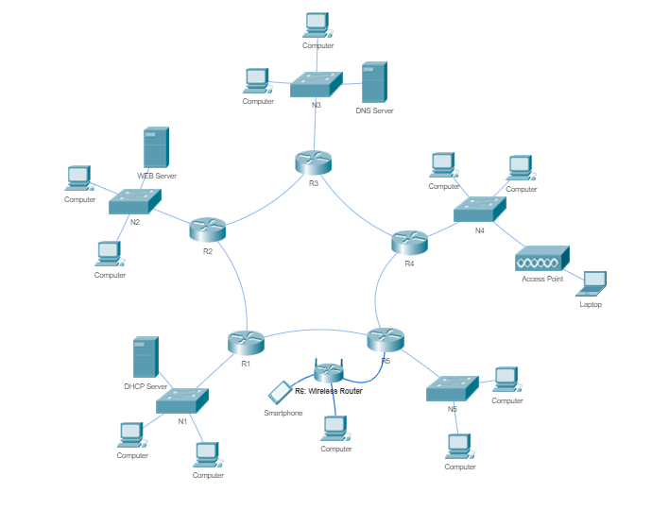

N1:192+3=195 (256)

N2:128+3 = 131 (256)

N3:80+3=83 (128)

N4:48+3 = 51 (64)

N5:16+3 = 21 (32)

N12:2+2 = 4

N23:2+2 = 4

N34:2+2 = 4

N45:2+2 = 4

N51:2+2 = 4

N5w:2+2 = 4

N1:232.136.120.0->232.136.120.255 R1: 232.136.120.1 S1: 232.136.120.2

N2:232.136.121.0->232.136.121.255 R2: 232.136.121.1 S2Web: 232.136.121.2

N3:232.136.122.0->232.136.122.127 R3: 232.136.122.1 S3DNS: 232.136.121.2

N4:232.136.122.128->232.136.122.191 R4: 232.136.122.129

N5:232.136.122.192->232.136.122.223 R5: 232.136.122.193

N12:232.136.122.224->232.136.122.227 R1: 232.136.122.225 R2: 232.136.122.226

N23:232.136.122.228->232.136.122.231 R2: 232.136.122.229 R3: 232.136.122.230

N34:232.136.122.232->232.136.122.235 R3: 232.136.122.233 R4: 232.136.122.234

N45:232.136.122.236->232.136.122.239 R4: 232.136.122.237 R5: 232.136.122.238

N51: 232.136.122.240->232.136.122.243 R5: 232.136.122.241 R1: 232.136.122.242

N5w: 232.136.122.244->232.136.122.247 R5: 232.136.122.245 Rw: 232.136.122.24x6